WIFI W3fancoil unit thermostat manual
  Search for "Smart RM" or “Smart Life” Download the Wifi App from Google Play or APP Store   | Turn on the thermostat, press and hold the key combination “” and “” Activate WIFI distribution network icon
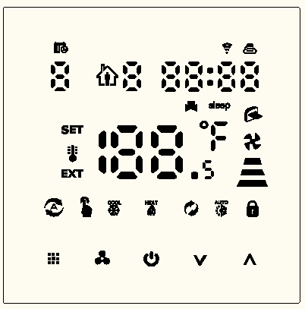
Technical data
Voltage: AC230V, Output：On/off type
Current: 3A Display temperature range：0~70°C
Accuracy: ±0.5ºC Work environment:：-10~60°C
Setting range: 5ºC - 35ºC Size：86 * 86mm
Sensor:： NTC(10k)1%
Button
Icon | Description
 | Increase key: short press to adjust data,long press to check external senor temperature (When the sensor type is N3 in the advanced option)
 | Mode switching key: short press to switch between manual mode and program mode, long press to set special function parameters
 | Decrease key：short press to adjust data, long press to lock/unlock keys
 | Fan speed selection key: short press to set fan speed (confirm key when setting parameters), long press to enter sleep function setting
 | Power key
 | Press them together to enter matching wifi mode
WIFI connection, flashing as EZ wifi pair mode
 Wifi status: Disconnection  Child lock
 cloud icon ,if flashing ,then enter AP wifi pair mode
 Program mode;run preset program  Manual mode
 Temporary manual mode  Clock
 Holiday mode, Holiday days and temperature can be set to run in countdown mode
Operation

Operation | Description
Fan Speed | Power on state ,press“”to choose fan speed （high ）、（mid ）、（low）、（Auto animation）
Setting time | Power on state, press“”3-5s ，chose ，then press“” to set time：  Minute“mm”flashing，press“”or“”to adjust，press“”to next setting.as same method to set hour and week.finally press or wait 5S to exit
Timer | After connected wifi ,click “cloud” on the right corner of APP to set
Working mode | Power on state,long press“”3-5S, short press to choose ,next press to choose mode:   “ ” is mean cooling mode,“”is mean heating mode,“ ”is mean ventilation mode； is mean auto mode
Control valve | When cooling mode(heating mode),indoor temperature more（lower) 1℃ than setting temperature, open valve; after equal, closed valve,fan is still running.  Ventilation mode（fan is not control by temperature as default）  If fan be controlled by temperature,then valve and fan will be closed.
Locked function | long press to lock/unlock keys
Alarm | E1 ：inner sensor alarm  E2 ：external sensor alarm
Sleep mode | Power on state, long press , is flashing, short press to run it，short press to cancel  Remark：Sleep mode is not available when run ventilate mode or auto mode
Manual/ program mode | Power on state, short press“” to switch manual mode/program mode
Program mode setting
Thermostat support set different time and different temperature；Compatible with 5+2,6+1,7days
Program mode type
Long press 3-5S，next short press to choose，then short press to program mode setting，use and to adjust value . After short press to set next time section setting
Time section |  | Icon | Time (default) | Temperature(default)
Monday to Sunday | 1 |  | 06:00 | 20°C
Monday to Sunday | 2 |  | 08:00 | 15°C
Monday to Sunday | 3 |  | 17:30 | 22°C
Monday to Sunday | 4 |  | 22:00 | 15°C
Advanced Option
Turn off thermostat ,long press 5S to enter advanced setting options, Short press to set next item, press“”or“”to set item data
Symbol | Item | Parameter | Default
A1 | Temperature  Calibration | -9-+9℃ | -1℃
A2 | Children Lock | 0：half lock；（It is available to turn on/off and adjust temperature）  1：full lock | 0
A3 | Setting the lowest limit temperature | 5-15℃ | 5℃
A4 | Setting the highest limit temperature | 16-50℃ | 35℃
A5 | Fan energy saving control | 0: valve off,fan off  1: valve off,fan always on | 0
A6 | Programmable | 0=5+2  1=6+1  2=7 (everyday all the same) | 0
A7 | Choose valve output | 2:2pipe  4:4 pipe | 4
A8 | Choose sensor | N1:inner sensor  N2:external sensor  N3:Double sensor when choose N3，In the heating state, normally only valve is opened , and the fan is turned on when the external temperature is detected to be ≥X°C. When the temperature is detected to be lower than (X-2) °C, the fan is turned off. | N1
A9 | Set temperature for external sensor | 20-60°C | 38°C
AA | Standby bright | 0: off  1: weak bright  2: brighter | 1
AB | Reset | Display Ao, press  key until whole show | Ao
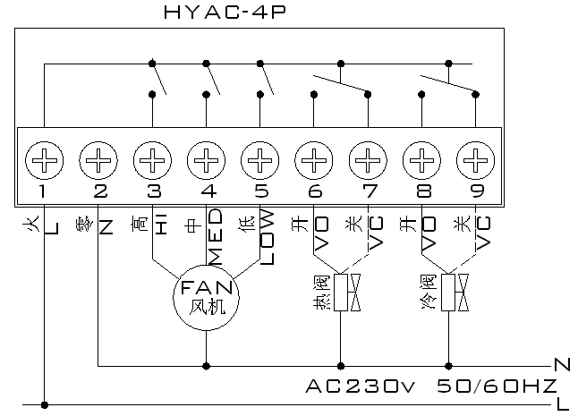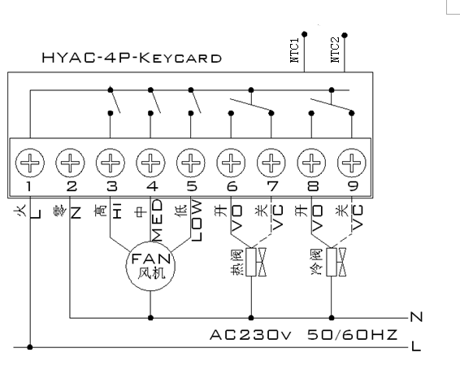
Cautions on Installation:
1.To prevent the thermostat display from a high fluctuation, special treatment has been made to the program. Therefore, it is normal that the thermostat cannot immediately display the sudden change of temperature.
2. The thermostat installed on 1.5m above the ground.
3.For the thermostat installed,please take care not to install it to the wall corner, door / window side or behind the door or in such unheated area as exterior wall. Avoid hot / cold air duct, radiator, flue or thermal pipe
4 When install the power supply, make sure that the power cable is well insulated.
5.Don’t open the internal circuit board..
6.HYAC series thermostat design for the standard 75x75x 35mm wall mount box installed. Follow the instructions to open the rear cover base, mount it on the wall and wire it.
7.Before installing the thermostat, make sure that the system is disconnected. The maximum voltage of the system shall meet the requirements specified in the Instruction Manual (Max. AC Voltage: 250V).

